Solving Euclidean Minimal Spanning Tree Problem Using a New Meta-heuristic Approach: Imperialist Competitive Algorithm (ICA)

  - M. Hosseini¹, A. A. Khaled², M. Jin³

- Department of Industrial and Systems Engineering, Mississippi State University, Mississippi State, USA

²Department of Industrial and Systems Engineering, Mississippi State University, Mississippi State, USA
³Department of Industrial and Systems Engineering, The University of Tennessee, Knoxville, USA
(¹s.m.hosseini48@gmail.com, ²ak511@msstate.edu, ³jin@utk.edu)

Abstract – The minimum spanning tree (MST) problem has |  |  |  |  |  | Many researches have been conducted to investigate
numerous applications in design of communication, |  |  |  |  |  | the MST problem. The first algorithm was introduced by
computer and transportation networks. This paper proposes |  |  |  |  |  | Boruvka in 1926 [1] and has the computational
an application of a new meta-heuristic called Imperialist |  |  |  |  |  | complexity | of. Two |  | most | well-known
Competitive algorithm (ICA) for solving a special case of |  |  |  |  |  | algorithms are greedy algorithms developed by Kruskal
MST defined |  | on a Euclidean | plane, called the Euclidean
 |  | on a Euclidean |  |  |  | and by Prim with computational complexity of
minimum spanning tree (EMST) problem. ICA is inspired by
 |  |  |  |  |  | andrespectively [2]. |  |  | Neuman and Witt
human’s socio-political evolution. The solution quality and
speed of the proposed are verified by numerical examples |  |  |  |  |  | proposed a heuristic based on ant colony optimization
compared to a commercial optimization solver. |  |  |  |  |  | (ACO) using the random walk concept [3].
Keywords - Spanning tree, ICA, EMST |  |  |  |  |  | This paper deals with a special class of the MST
 |  |  |  |  |  | problem in which all pairs of vertices in a Euclidean plane
 |  |  |  |  |  | are connected with an edge with the cost associated to the
 |  | I. INTRODUCTION |  |  |  | Euclidean distance. It is known as the Euclidean minimum
 |  |  |  |  |  | spanning tree (EMST) problem. The most straightforward
The minimum spanning tree (MST) problem is among |  |  |  |  |  | algorithm for the EMST problem with vertices actually
 |  |  |  |  |  | constructs | the complete | graph containingെ Ȁ
the most | important problems |  | in | the graph theory | with | constructs | the complete
 |  |  |  |  |  | edges where each edge cost is computed by finding the
numerous | applications, such |  | as | transportation network
 |  |  |  |  |  | distance between each pair of points and then runs either
design and data transferring in a communication network.
 |  |  |  |  |  | Prim’s or Krushal’s algorithm [4]. Earlier works on EMST
The problem is defined on a graph ൌ ǡ , where is
 |  |  |  |  |  | can be found in [5-7]. More recently, March et al. [8]
the vertex set with ȁ ȁ ൌ and is the undirected edge |  |  |  |  |  | introduced a fast and general EMST algorithm based on
set with ȁ ȁ ൌ . Every edge א is associated |  |  |  |  | with | clustering and analysis of astronomical data. The running
non-negative cost . A minimum spanning tree is defined |  |  |  |  |  | time of all above work on EMST is |  |  |  | equivalent to
as a connected sub graph of having no cycle and |  |  |  |  |  | .
covering all vertices in with the minimum cost. The |  |  |  |  |  | Traditional approaches for solving the EMST problem
MST problem can be formulated as the following integer |  |  |  |  |  | scale quadratically and their computational time increases
program (IP). |  |  |  |  |  | fast when the number of vertices and edges increases.
 |  |  |  |  |  | Hence, meta-heuristic approaches could be appropriate
Minimize |  |  |  |  | (1) | alternatives | for solving | EMST problems |  | with a large
 |  |  |  |  | (1) | number of | vertices and | edges. This | paper proposes an
 |  | אா
S.T. |  | אா |  |  |  | algorithm based on a relatively new meta-heuristic
 |  | ൌ െ |  |  | (2) | procedure called imperialist competitive algorithm (ICA).
 |  | ൌ െ |  |  | (2) | The remainder of the paper is organized as follows.
 |  | אா |  |  |  | Section II briefly introduces ICA. Section III describes the
 |  | ȁ ȁ െ |  | ǡ ് | (3) | detailed procedure for implementing ICA to solve the
 |  |  |  | ǡ ് | (3) | EMST problem with two numerical examples. Finally,
 |  | אா ௌ |  |  |  | Section IV concludes the paper and discusses future
 |  | א ǡ . |  |  | (4) | research directions.

The objective function (1) minimizes the sum of costs of the edges in the selected spanning tree. Constraint (2) refers to a cardinality constraint ensuring that we choose exactly െ edges. Constraint set (3) is known as the sub-tour elimination constraints implying that the set of chosen edges contain no cycles. is the set of edges in

whose both ends belong to the vertex set . The binary decision variable in (4) takes value 1 if edge is selected and 0 otherwise.

II. IMPERIALIST COMPETITIVE ALGORITHM

ICA is a new population-based heuristic algorithm inspired by human’s socio-political evolution [9]. Although this is a new meta-heuristic approach, its application is widespread in solving many complex optimization problems such as job-shop scheduling, vehicle routing, traveling salesman, and quadratic assignment problems. Some recent works on the

978-1-4673-2945-3/12/$31.00 ©2012 IEEE 176

Proceedings of the 2012 IEEE IEEM

application of ICA can be found in [10-12]. Their results indicate that the run time of ICA is averagely less than other algorithms.

ICA starts with an initial population in analogy with most of the evolutionary algorithms (e.g., Genetic Algorithm (GA), Particle Swarm Optimization (PSO), ACO). Each population individual in ICA is called a country, equivalent to a particle in PSO and a chromosome in GA. Each country is associated with a cost. In the initialization step for a minimization problem, some of the countries with the least cost in the population are selected as imperialists, and then the rest of population, called colonies, is divided and allocated to imperialists based on their powers. The power of each country is defined as an inverse of its cost. A collection of an imperialist and its colonies form an empire. After forming initial empires, the colonies in each empire start moving toward their relevant imperialist country. This process is known as the assimilation process, illustrated in Fig. 1, where the imperialist country absorbs its colony in the language and culture axes. represents the distance between the colony and its imperialist. The colony in Fig. 1 moves toward the imperialist country to the new position along with extent of . Here, is a random variable with a uniform distribution and can be represented as
̱ ǡ ൈ . | (5)

Imperialist
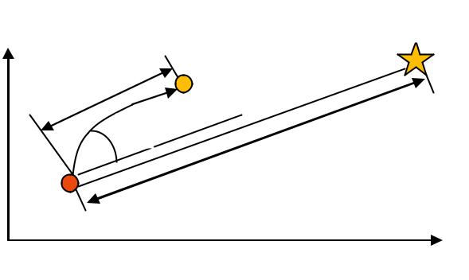

 | New position
x | of colony
Language
 | d
Colony

Culture

Fig. 1. Movement of colony toward its relevant imperialist [9].

New position

of colony
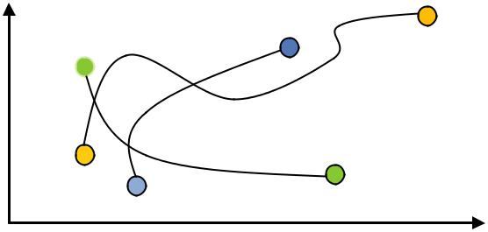

Language
Colony

Culture

Fig. 2. Revolution process of countries [9].
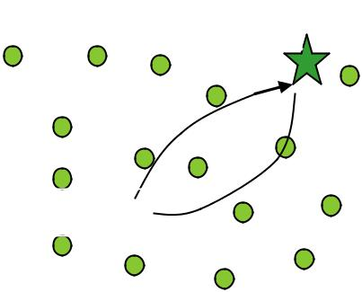

Imperialist

The value of is typically greater than 1. The human history of the imperialism indicates that the assimilation cannot be performed desirably. Therefore, a random deviation parameter is considered in the direction of a colony movement. The variation range of is determined by an arbitrary parameter . Large values of facilitate the global diversification while smaller values encourage local intensification. In Fig. 1, the value of is usually expressed in terms of radian and also determined using a uniform distribution given in (6). In most of implementations the values of and at about 2 and Ȁ respectively result in good convergence of ICA to the global minimum.
̱ ǡ . | (6)

Similar to the mutation process in GA, ICA introduces

- sudden change in socio-political characteristic of a country, known as revolution. In the optimization domain, a revolution means that a solution jumps randomly over the space to control the global diversification of countries. Revolutions prevent the algorithm’s convergence to local optima at early iterations. Fig. 2 shows a revolution event.

After assimilation and revolution processes, the costs of colonies in an empire are compared with the imperialist in the empire. If there is any colony with lower cost, the colony with the lowest cost and the imperialist exchange their positions. Fig. 3 shows the exchange process between a colony and the imperialist in an empire.

Colony 

Fig. 3. Exchange positions of imperialist and colony in an empire [9].

The total power of an empire is determined based on the cost of its imperialist plus part of the mean cost of its colonies, as shown in (7).

ൌ ൈ
(7)
.

represents the total cost of the n^{th} empire out of the total empires and is a non-negative number smaller than one. When approaches zero, the total empire cost will be dominated by the cost of its imperialist. Empirical studies in the literature show that ൌ Ǥ often result in good solutions.

The most important part of ICA is the competition among imperialists. During the competition process, all empires try to capture colonies of other empires. This imperialist competition gradually decreases the power of weaker empires and increases that of powerful ones. This fact can be modeled by assigning the weakest colony of the weakest empire to another empire. The likelihood of taking possession of a colony by an empire is determined

177

Proceedings of the 2012 IEEE IEEM

based on the empire’s own total power. Fig. 4 illustrates the imperialist competition process.
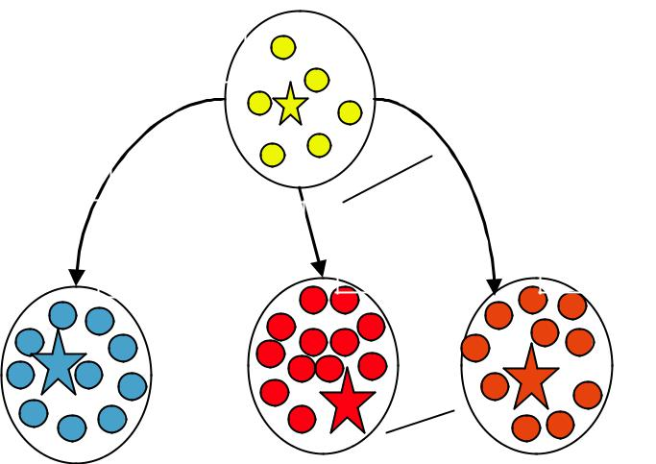

Empire 1

(The weakest one)

_{ʹ}
 | ͵
Empire 2 | Empire 3 | Empire N

Fig. 4. Empire competition to capture the weakest colony [9].

To obtain the possession probability of each empire, the total cost of each empire is normalized as in (8).
ൌെ Ǥ | (8)
ǡǥǡ

ൌ ǡ _{ଶ}ǡ ǥ ǡ ே . | (11)

Vector is created by subtracting from as (12) to add more randomness in the algorithm.
ൌ െ ൌ െ ǡ _{ʹ} െ _{ʹ}ǡ ǥ ǡ െ ே . (12)

Based on vector , we assign the weakest colony to the empire that has the largest value in . The advantage of this mechanism over the roulette wheel rule used in GA is that we do not need to calculate any cumulative density functions so that the imperialist competition mechanism has less computational burden than the roulette wheel rule. During the imperialist competition, powerless empires gradually lose their colonies and will be collapsed over time. Finally all colonies will be captured and controlled by the most powerful empire, which is unique. At this point, ICA converges to an ideal solution, which is the only imperialist in the population, and can be considered as a stopping criterion. In addition, the maximum number of iterations can also be used as a stopping criterion. The flowchart of ICA is shown in Fig. 5.

Here,andrepresent total and normalized cost |  |  |  | III. IMPLEMENTION OF ICA TO EMST
of the n^{th} empire respectively. The probability of capturing |  |  |  | This section describes the details of implementing
the weakest colony by the n^{th} empire is computed by (9). |  |  |  | This section describes the details of implementing
 |  |  |  | ICA to the EMST problem.
ൌ ฬ |  | ฬ. | (9) | A. Representation of the Countries
ൌ ฬ | ಿ | ฬ. | (9) | A. Representation of the Countries
 | ^{σ} ൌ |  |  | A. Representation of the Countries
The capturing probabilities of empires are represented by |  |  |  | Each country is represented by a vector of size ,
a ൈ vector as in (10). |  |  |  | which is the number of decision variables in model (1-4)
ൌ ǡ _{ଶ}ǡ ǥ ǡ ே]. |  |  | (10) | and the number edges in . For instance, the graph with
 |  |  | (10) | ൌ vertices and ൌ edges in Fig. 6 along with its
Another vector with the same size as is created |  |  |  | adjacency matrix , each country is a vector of size 5. All
 |  |  |  | entries in a country vector take values of 0 or 1.
with elements generated by a uniform distribution in (11).
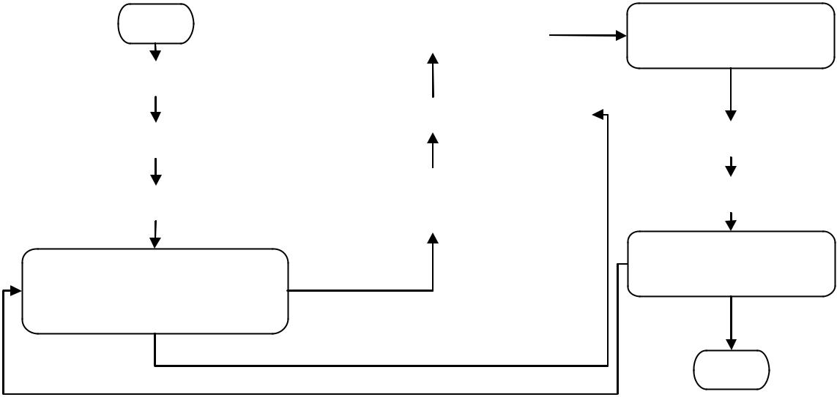

 |  | Start |  |  |  |  | Imperialistic Competition |  |  |  |  |  | Is there an empire
 |  |  |  |  |  |  |  |  |  |  |  |  | with no colonies?
 |  | Initialize the empires
 |  | Initialize the empires |  |  |  |  |  |  |  |  |  |  |  | Yes
 |  |  |  |  | Compute the total cost of all empires
 |  | Assimilate colonies |  |  |  |  |  |  |  |  |  |  | Eliminate this empire
 |  |  |  |  |  |  | Exchange the positions of that
 |  | Revolve some colonies |  |  |  |  |  |  |  |  |  |  | Unite Similar Empires
 |  |  |  |  |  |  | imperialist and the colony
 |  |  |  |  |  |  |  |  |  |  |  |  | Stopping condition
Is there a colony in an empire
 |  |  |  |  |  |  |  |  |  |  |  |  | satisfied?
 | which has lower cost than |  |  |  |  |  |  | Yes
 |  | that of the imperialist? |  |  |  |  |  |  |  |  |  |  |  | Yes

 |  |  | No |  | END
Fig. | No |  |  |  | END
Fig. | 5. Flowchart of Imperialist Competitive Algorithm (ICA) [9].

178

Proceedings of the 2012 IEEE IEEM

Based on the Connectivity Theorem, is defined in (17).
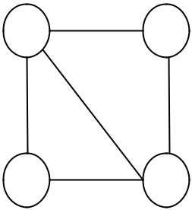

- B

ൌ

- D

Fig. 6. Example graph with four vertices and its adjacency matrix

B. The Cost Function

To apply ICA to the EMST problem, the cost function ǁfor a given solution (country) is defined in (13). The cost function includes a penalty to those solutions that violate the connectivity (feasibility) condition (3) in addition to edge costs. The objective of the EMST problem is to find the solution to minimize ǁ.
ǁ σ _{אா} Ǥ | (13)

Here, is the Euclidian distance between the two ends ǡ of as (14).

ൌ |  | െ ^{ଶ}െ ^{ଶ}Ǥ |  | (14)

Here, ǡ is the coordinates of vertex . In (13), denotes a large enough penalty rate for solution disconnectivity and is a parameter measuring disconnectivity of the graph formed by edges with ൌ in the current solution. In order to calculate , we review the Connectivity Theorem in the graph theory below.

Connectivity Theorem: Let ൌ ǡ be a graph and A be its adjacency matrix. G is strongly connected if and only if matrix defined in (15) has no zero entries, where
ൌڮ ^{௩ି} Ǥ | (15)

Proof: Let G be a graph with v vertices. and ^{ଶ} are

the ^{୦} entries of and ^{ଶ} respectively. Based on the rules of matrix multiplication, we have
^{ଶ} | ൌ ଶ ଶ ^{ڮ} ௩ ௩ ^{Ǥ} | (16)

^{ଶ} is the total possible walks with length 2 from vertex i to vertex j. Similarly, as the ^{୦} element of matrix is the total possible walks from vertex i to vertex j with length , where െ Ǥ Therefore, , the ^{௧} element of , is the total number of walks with length of less than from vertex i to vertex j. G is called strongly connected if and only if there are walks with length small
than for each pair ǡ in G. ז

ൌ | ୬ ୫ୠ ୰ ୭ ୰୭ ୧୬ | Ǥ | (17)
 | _{௩}మ

Fig. 7 shows an example graph G with 4 vertices and 3 edges along with its adjacency matrix A and matrix . Matrix has six zero entries, indicating that graph is not strongly connected. The disconnectivity percentage of
is ൌ ൌ Ǥ ΨǤ

ൌ
ൌ
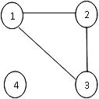
Fig. 7. Example graph for disconnectivity measure

C. Assimilation process

As mentioned earlier, the assimilation process let the colonies move toward the imperialist through a continuous search while EMST is defined as a discrete problem. To keep all variables binary, we round up to 1 if Ǥ in a solution (country) after the assimilation process. Otherwise, is rounded down to 0.5. This may cause a solution (country) violates constraint (2). However, a solution with σ _{אா} െ is penalized in the cost function (13) due to the disconnectivity while a solution with σ _{אா} െ is penalized by the additional cost of including too many edges in the first term of (13). Therefore, any infeasible solution has larger cost and become a weaker country in ICA.

D. Parameters tuning

The performance of ICA depends on how to tune the ICA parameters. We have implemented the parameters tuning experiment for the second example in Subsection E. This experimentation is achieved by two steps:

Step 1) Setting the number of iterations: We let the number of iterations vary from 200 to 1,200. As shown in Fig. 8, after the 800th iteration, there is no remarkable improvement on cost, so the maximum number of iterations is set to be 800.

Step 2) Determining the number of countries: The numbers of countries are tested from 60 to 180 with an increment of 20. Fig. 9 shows that the number of countries can be set at 140 since there is no significant improvement beyond this point.

Other ICA parameters are set as follows: the number of imperialist countries is considered as 10% of total countries (14 imperialist for Example 2). Mean cost coefficient and assimilation coefficient of colonies are set to 0.1 and 2 respectively.

179

Proceedings of the 2012 IEEE IEEM

800
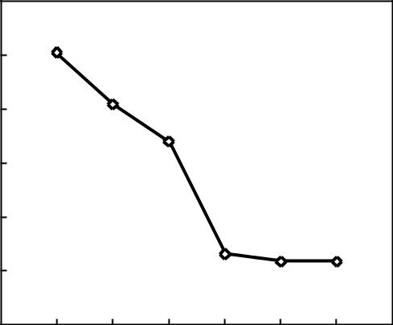

 | 750
 | 700
Cost | 650
 | 600

550

500

- 200 400 600 800 1000 1200 1400

Number of Iterations

Fig. 8. The impact of ICA’s number of iterations on generated solution.

 | 620
 | 610
 | 600
Cost | 590
Cost | 580
 | 570
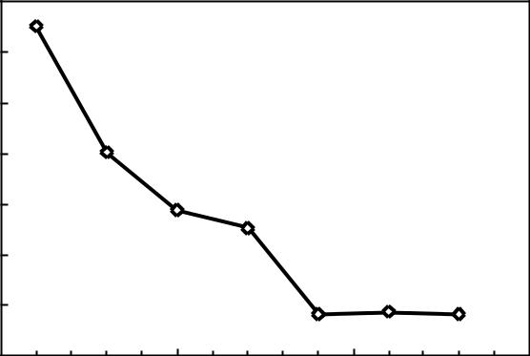

560

550

50 100 150 200

Number of Countries

Fig. 9. The impact of ICA’s number of countries on generated solution.

E. Illustrative examples

The following two example EMST problems are presented to illustrate the proposed ICA.

Example 1: The graph contains 6 vertices and 15 edges as shown in Fig. 10. The distance matrix is given in TABLE I. In Fig. 10, horizontal and vertical axes represent

- and ݕ coordinates of vertices respectively. This small size EMST problem is solved by ICA and the solution is plotted in Fig. 11.

40
35
30
25
20
15
10
5
0 | 5 | 10 | 15 | 20 | 25 | 30 | 35
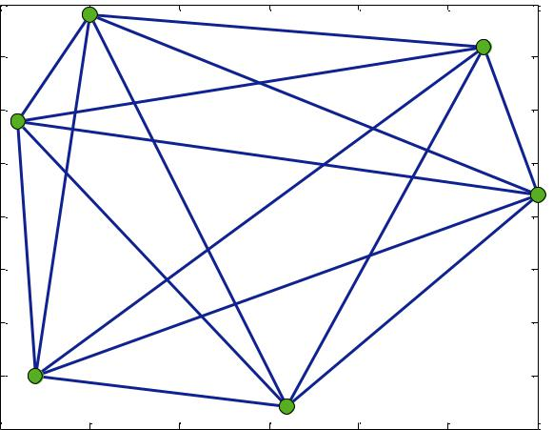

Fig. 10. Graph of Example 1

TABLE I
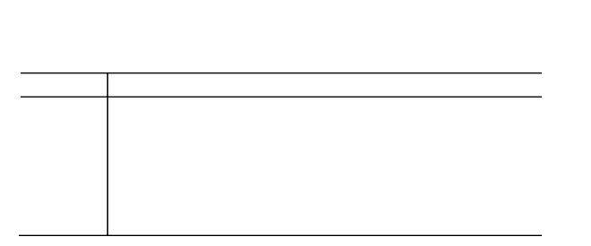

 | DISTANCE MATRIX OF EXAMPLE I
Node | 1 | 2 | 3 | 4 | 5 | 6
1 | 0 | 24.02 | 26.93 | 30.89 | 29.83 | 10.77
2 | 24.02 | 0 | 39.82 | 14.32 | 32.76 | 34.13
3 | 26.93 | 39.82 | 0 | 35.74 | 14.32 | 22.20
4 | 30.89 | 14.32 | 35.74 | 0 | 24.41 | 38.60
5 | 29.83 | 32.76 | 14.32 | 24.41 | 0 | 30.23
6 | 10.77 | 34.13 | 22.20 | 38.60 | 30.23 | 0
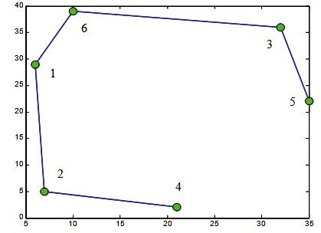

Fig. 11. Minimum spanning tree obtained by ICA for Example 1

Example 2: The graph contains 15 vertices and 105 edges. Its distance matrix is given in TABLE II. The solution obtained by ICA is plot in Fig.12 and its convergence is illustrated in Fig. 13. ICA took 18.27 seconds and 630 iterations to converge.
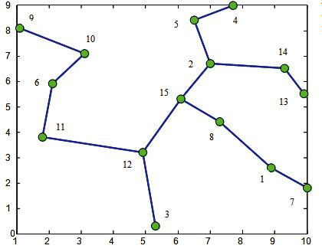

Fig. 12. Minimal spanning tree obtained by ICA for Example 2

 | 4000
 | 3500
 | 3000
Cost | 2500
 | 2000
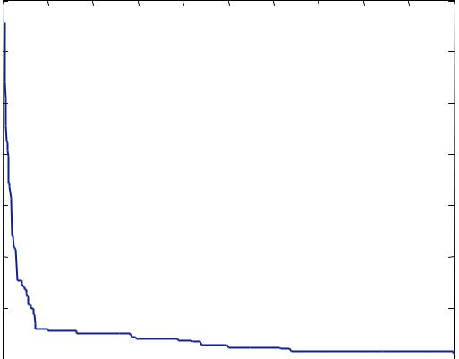

1500

1000

500

0 100 200 300 400 500 600 700 800 900 1000
Iteration
Number of Iteration
Fig. 13. Convergence diagram for Example 2.

180

Proceedings of the 2012 IEEE IEEM

TABLE II


 |  |  |  |  |  | DISTANCE MATRIX OF EXAMPLE 2
Node | 1 | 2 | 3 | 4 | 5 | 6 | 7 | 8 | 9 | 10 | 11 | 12 | 13 | 14 | 15
1 | 0 | 45.19 | 42.72 | 65.12 | 62.77 | 75.58 | 13.60 | 24.08 | 95.44 | 73.41 | 72.01 | 40.45 | 30.68 | 39.20 | 38.90
2 | 45.19 | 0 | 66.22 | 24.04 | 17.72 | 49.65 | 57.45 | 23.19 | 60.64 | 39.20 | 59.54 | 40.82 | 31.38 | 23.09 | 16.64
3 | 42.72 | 66.22 | 0 | 90.25 | 81.88 | 64.50 | 49.34 | 45.62 | 88.59 | 71.47 | 49.50 | 29.27 | 69.43 | 73.78 | 50.64
4 | 65.12 | 24.04 | 90.25 | 0 | 13.42 | 64.01 | 75.58 | 46.17 | 66.61 | 49.77 | 78.64 | 64.40 | 41.34 | 29.68 | 40.31
5 | 62.77 | 17.72 | 81.88 | 13.42 | 0 | 50.61 | 74.71 | 40.79 | 54.08 | 36.40 | 65.76 | 54.41 | 44.69 | 33.84 | 31.26
6 | 75.58 | 49.65 | 64.50 | 64.01 | 50.61 | 0 | 89.01 | 54.12 | 24.17 | 15.62 | 21.21 | 38.90 | 78.10 | 72.25 | 40.45
7 | 13.60 | 57.45 | 49.34 | 75.58 | 74.71 | 89.01 | 0 | 37.48 | 109.04 | 87.01 | 84.40 | 52.89 | 37.01 | 47.52 | 52.40
8 | 24.08 | 23.19 | 45.62 | 46.17 | 40.79 | 54.12 | 37.48 | 0 | 72.20 | 49.93 | 55.33 | 26.83 | 28.23 | 29.00 | 15.00
9 | 95.44 | 60.64 | 88.59 | 66.61 | 54.08 | 24.17 | 109.04 | 72.20 | 0 | 22.36 | 43.57 | 62.01 | 91.76 | 83.55 | 57.31
10 | 73.41 | 39.20 | 71.47 | 49.77 | 36.40 | 15.62 | 87.01 | 49.93 | 22.36 | 0 | 35.47 | 42.95 | 69.86 | 62.29 | 34.99
11 | 72.01 | 59.54 | 49.50 | 78.64 | 65.76 | 21.21 | 84.40 | 55.33 | 43.57 | 35.47 | 0 | 31.58 | 82.76 | 79.71 | 45.54
12 | 40.45 | 40.82 | 29.27 | 64.40 | 54.41 | 38.90 | 52.89 | 26.83 | 62.01 | 42.95 | 31.58 | 0 | 55.04 | 55.00 | 24.19
13 | 30.68 | 31.38 | 69.43 | 41.34 | 44.69 | 78.10 | 37.01 | 28.23 | 91.76 | 69.86 | 82.76 | 55.04 | 0 | 11.66 | 38.05
14 | 39.20 | 23.09 | 73.78 | 29.68 | 33.84 | 72.25 | 47.52 | 29.00 | 83.55 | 62.29 | 79.71 | 55.00 | 11.66 | 0 | 34.18
15 | 38.90 | 16.64 | 50.64 | 40.31 | 31.26 | 40.45 | 52.40 | 15.00 | 57.31 | 34.99 | 45.54 | 24.19 | 38.05 | 34.18 | 0

Both examples are also solved by LINGO, a commercial solver. TABLE III summarizes the performance of ICA against LINGO. Both algorithms reached the same minimum spanning tree but ICA took much less computational time.

TABLE III
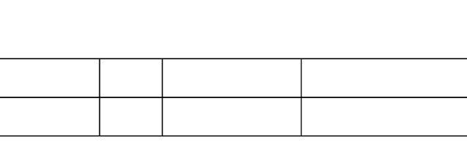

RESULTS FROM ICA AND LINGO

Graph |  | Size | Solution Cost |  | Run Time (Second)
Graph |  |  | ICA | LINGO | ICA | LINGO
Example 1 | 6 | 15 | 85.63 | 85.63 | 1.81 | 2.17
Example 2 | 15 | 105 | 279.44 | 279.44 | 7.85 | 18.62

IV. CONCLUSION

This paper applies ICA, a new meta-heuristic algorithm, to the EMST problem. The efficiency of the proposed algorithm was demonstrated by two illustrative examples. Both of the examples supports that the proposed algorithm is fast and yields quality solutions. The following recommendations are given for future research.

- Implementing ICA to other minimum spanning tree problems such as degree constraint minimum spanning tree (DMST) and capacitated minimum spanning tree (CMST) problems. Both are NP-hard problems.

- Developing a hybrid technique to DMST and CMST problems that considers the combination of two or more meta-heuristics. For example, ICA may be integrated with GA, Tabu Search, or ACO.

REFERENCES

- J. Nesetril, “Otakar Boruvka on minimum spanning tree problem Translation of both the 1926 papers, comments, history,” Discrete Math., vol. 233, pp. 3–36, 2001.
- C. F. Bazlamacci and K. S. Hindi, “Minimum-weight spanning tree algorithms: A survey and empirical study,” Computers Oper Res, vol. 28, no. 8, pp. 767–785, 2001.

- F. Neumann and C. Witt, “Ant colony optimization and the minimum spanning tree problem,” Theoretical Comput Sci, vol. 411, no. 25, pp. 2406-2413, 2010.
- T. H. Cormen, C. E. Leiserson, R. L. Rivest and C. Stein, Introduction to Algorithms, Cambridge, MA: MIT Press, 2009, pp. 631–642.
- J. Bentley and J. Friedman, “Fast Algorithms for Constructing Minimal Spanning Trees in Coordinate Spaces,” IEEE Trans. Comput., vol. 27, pp. 97–105, 1978.
- A. Yao, “On constructing minimum spanning trees in k-dimensional spaces and related problems,” SIAM J. Comput., vol. 11, no. 4, pp. 721–736, 1982.
- P. K. Agarwal, H. Edelsbrunner, O. Schwarzkopf and E. Welzl, “Euclidean minimum spanning trees and bichromatic closest pairs,” Discrete Comput. Geom., vol. 6, pp. 407– 422, 1991.

- W. B. March, P. Ram and A. G. Gray, “Fast Euclidean minimum spanning tree: algorithm, analysis, and applications,” in Proc. 16th ACM SIGKDD international conference on Knowledge discovery and data mining, KDD '10, New York, NY, pp. 603–612, 2010.

- E. A-Gargari and C. Lucas, “Imperialist competitive algorithm: An algorithm for optimization inspired by imperialistic competition,” in IEEE Congress on Evolutionary Computation, CEC'07, Singapore, pp. 4661-4667, 2007.

- J. Behnamian and M. Zandieh, “A discrete colonial competitive algorithm for hybrid flowshop scheduling to minimize earliness and quadratic tardiness penalties,” Expert Syst. Appl., vol. 38, no. 12, pp. 14490-14498, 2011.

- L. K. Shahvandi, M. Teshnehlab and A. Haroonabadi, “Multi-level clustering by imperialist competitive algorithm in wireless sensor networks,” International J. Adv. Eng. Sci. Technol., vol. 9, no. 2, pp. 327-332, 2011.

- S. Moadi, A. S. Mohaymany and M. Babaei, “Application of imperialist competitive algorithm to the emergency medical services location problem,” International J. Artif. Intell. Appl., vol. 2, no. 4, 2011.

181

